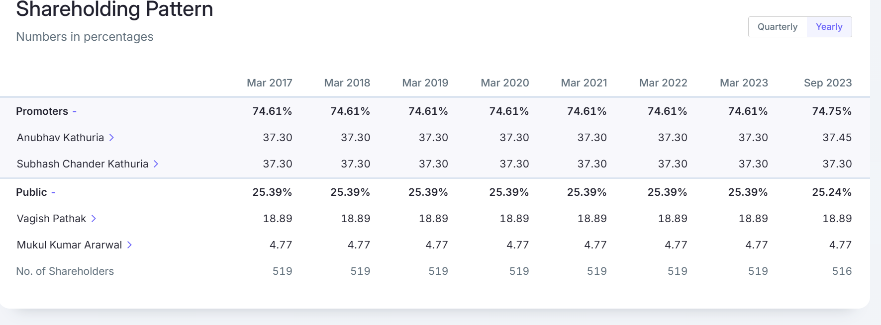
(Source:https://www.screener.in/company/id/1273228/#shareholding)

